https://lh6.googleusercontent.com/yOGQaiPJO2d4m_1cZJqtubj4nehnEfBZGO7PvkXWc1kEtV5PT71rQ15Eyi3iJV5FFCZGgREJgdJTHrEj4h5WdBQnh4mQGe4BlwfVJq7FyQdU5agG21Bvri21hScJVn7TN_cC7XeFUYyFQjGArmbCKUs

LOW LEVEL DOCUMENT **CREDIT CARD DEFAULT PREDICTION**

***August 21, 2022***

***Written BY OTHMANE ZOUBAIRI***

1 | P a g e

FOOD RECOMMENDATION LLD ii

iii LOW LEVEL DESIGN (LLD)

Contents

**1. Introduction**.............................................................................................1

**1.1. What is Low-Level design document?** .......................................................2

**1.2.Scope**.......................................................................................................3

**2. Architecture**...................................................................................................4

**Architecture Description**...................................................................................4

**Data Description**..............................................................................................5

**data ingestion………………………………………………………………………………………5**

**Data validation…………………………………………………………………………………………6**

**Data Transformation**.......................................................................................6

**Model Trainer**...............................................................................................7

**Model Evaluation**............................................................................................7

**Model Pusher**...................................................................................................8

**Deployment**......................................................................................................9.

**Interface …………………………………………………………………………………………………10**

**Test Cases** .........................................................................................................

**DOCUMENT VERSION CONTROL**

Change Record

|  |  |  |  |
| --- | --- | --- | --- |
| Date Date | Version Version | Comments Comments | Author  Author |
| 10/07/2022 10/07/2022 | 0.1 0.1 | Introduction and  architecture defined | othmane zoubairi |
| 28/07/2022 28/07/2022 | 0.2 0.2 | Architecture updated  Architecture updated  and unit test case  and unit test case  defined  defined | othmane zoubairi |

Review

|  |  |  |  |
| --- | --- | --- | --- |
| Date | Version | Reviewer | Comments |
|  |  |  |  |

Approval Status

|  |  |  |  |
| --- | --- | --- | --- |
| Version | Reviewer | Approved By | Comments |
|  |  |  |  |

ABSTRACT

Financial threats are displaying a trend in the credit risk of  commercial banks as the incredible improvement in the  financial industry has arisen. In this way, one of the biggest  threats faces by commercial banks is the risk prediction of  credit clients. The goal is to predict the probability of credit  default based on the credit card owner's characteristics and  payment history.

With the help of Data Science and Machine learning technology,  I developed an application, which allows a banker to determine  the probability Of Default in just a few seconds.

1 Introduction

1.1 What is Low-Level design document?

The goal of LLD or a Low-level design document is to give an  internal logical design of the actual program code for the Credit  Card Default Probability Prediction. LLD describes the class  diagrams with the methods and relations between classes and

the program specs. It describes the modules so that the  programmer can directly code the program from the document.

1.2 Scope

**Low-level design (LLD) is a component level design process  that follows a step-by-step refinement process. This process  can be used for designing data structures, required software  architecture, source code and ultimately, performance  algorithms. Overall, the data organization may be defined during  requirement analysis and then defined during data design work.**

2 Architecture

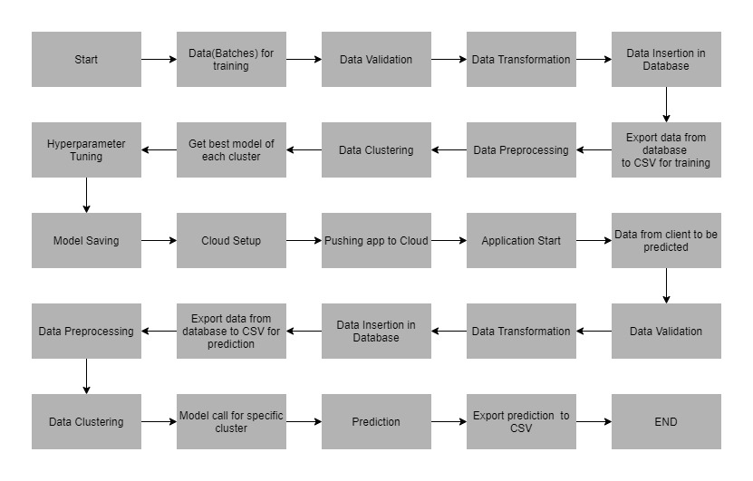

3 Architecture Description

3.1 Data Collection

**For training and testing the model I used a publicly available  dataset on Kaggle. This dataset contains information on default  payments, demographic factors, credit data, history of  payment, and bill statements of credit card clients in Taiwan  from April 2005 to September 2005.**

https://www.kaggle.com/datasets/uciml/default-of-credit card-clients-dataset

3.2 Data Dictionary

* **ID: ID of each client  droped because it is unnecessary**
* **LIMIT_BAL: Amount of given credit in NT dollars (includes individual and  family/supplementary credit**
* **SEX: Gender (1=male, 2=female)**
* **EDUCATION: (1=graduate school, 2=university, 3=high school, 4=others, 5=unknown,  6=unknown)**
* **MARRIAGE: Marital status (1=married, 2=single, 3=others)**
* **AGE: Age in years**
* **PAY_0: Repayment status in September, 2005 (-1=pay duly, 1=payment delay for one  month, 2=payment delay for two months, … 8=payment delay for eight months,  9=payment delay for nine months and above)**
* **PAY_2: Repayment status in August, 2005 (scale same as above)**
* **PAY_3: Repayment status in July, 2005 (scale same as above)**
* **PAY_4: Repayment status in June, 2005 (scale same as above)**
* **PAY_5: Repayment status in May, 2005 (scale same as above)**
* **PAY_6: Repayment status in April, 2005 (scale same as above)**
* **BILL_AMT1: Amount of bill statement in September, 2005 (NT dollar) • BILL_AMT2: Amount of bill statement in August, 2005 (NT dollar)**
* **BILL_AMT3: Amount of bill statement in July, 2005 (NT dollar)**
* **BILL_AMT4: Amount of bill statement in June, 2005 (NT dollar)**
* **BILL_AMT5: Amount of bill statement in May, 2005 (NT dollar)**
* **BILL_AMT6: Amount of bill statement in April, 2005 (NT dollar)**
* **PAY_AMT1: Amount of previous payment in September, 2005 (NT dollar) • PAY_AMT2: Amount of previous payment in August, 2005 (NT dollar) • PAY_AMT3: Amount of previous payment in July, 2005 (NT dollar)**
* **PAY_AMT4: Amount of previous payment in June, 2005 (NT dollar)**
* **PAY_AMT5: Amount of previous payment in May, 2005 (NT dollar)**
* **PAY_AMT6: Amount of previous payment in April, 2005 (NT dollar)**
* **default.payment.next.month: Default payment (1=yes, 0=no)**

**Summary Statistics**

**There are 25 columns .Out of which 20 are integer columns  and 4 are decimal columns.Total there are 30,000  transactions.**

3.3 Variable Information

**This is a classification problem. The target variable is  default.payment.next.month. The aim of the project is to predict  the probability of default given various attributes of the  customer given below.**

4. Data Ingestion

* data in data ingestion folder
* Split data in train and test data
* Saving data in data ingestion folder

4.1 Data Validation

* data in data validation folder
* data drift and EDA
* Report in evidently to show and analysis Data Distribution
* Saving report in data validation Folder

4.2 Data Transformation

* data in data Transformation folder
* Using Pipeline and columns transformer to processing Data
* Splitting data in array by Standard Scalar and different technique
* Putting train array data and test array data in transformation folder and creating prepossessing Object file.
* Saving Processing pkl in data transformation folder for future Transformation

1. **Model Trainer**

* We have built various models like Logistic Regression, Random Forest, Gradient Boosting, etc. • Each of the above models was built taking their default parameters.
* We have use Gridsearch CV to have best model in comparison all models
* We save best model file in Model Trainer folder

**5.1Data Evaluation**

* we used Metric for Classification : Recall Score, F1 Score and Model accuracy In train and test model to evaluate our best model
* we save the evaluation model in evaluation Folder
* Random Forest Classifier was the best Model
* Reason For Choosing This Model :
* Apart From a good training and test score, the reasons for  choosing this model are as follows :
* • Can handle missing values.
* • Can work well even on imbalanced data.

**5.2 Model Pusher**

* **The best model was Random Forest.**
* **The model has been saved in ‘Model.pkl’**
* **If we have an updated better model by new data ,**

**we can save it in model pusher save models folder**

**5.3 Heroku Deplyement**

* **I deployed the application on the web using Heroku**
* **The deployment part of the code runs in the “app.py” file, connecting with the web page designed using HTML with CSS  styles.The html front end template can be found in templates  folder.**

  6 User Interface

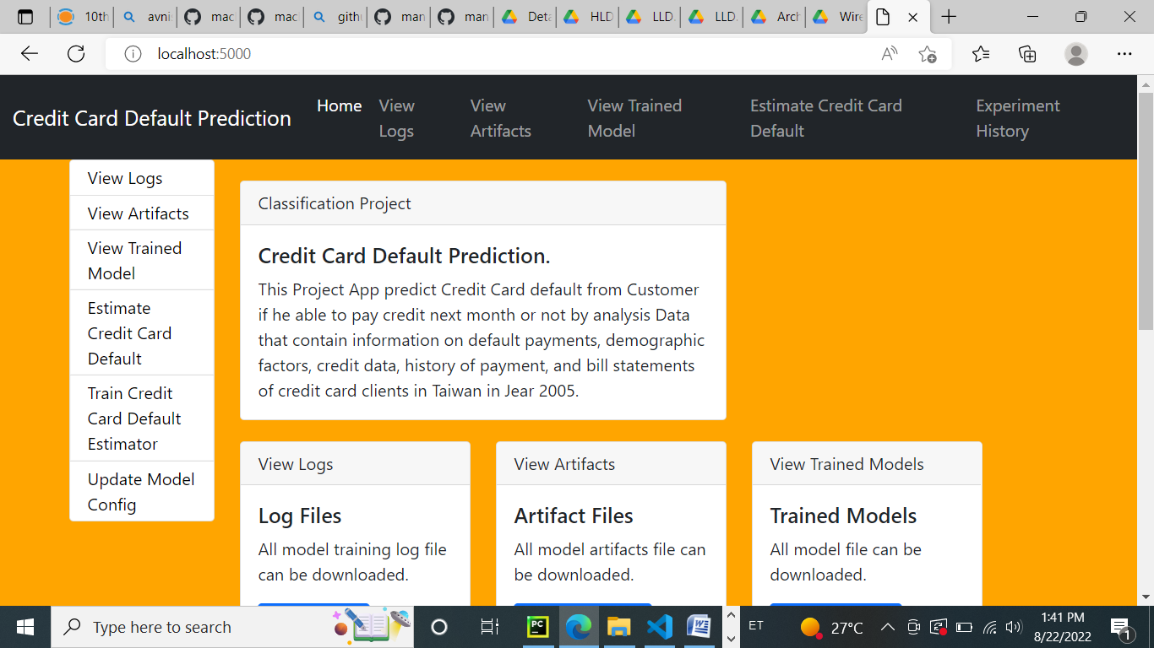

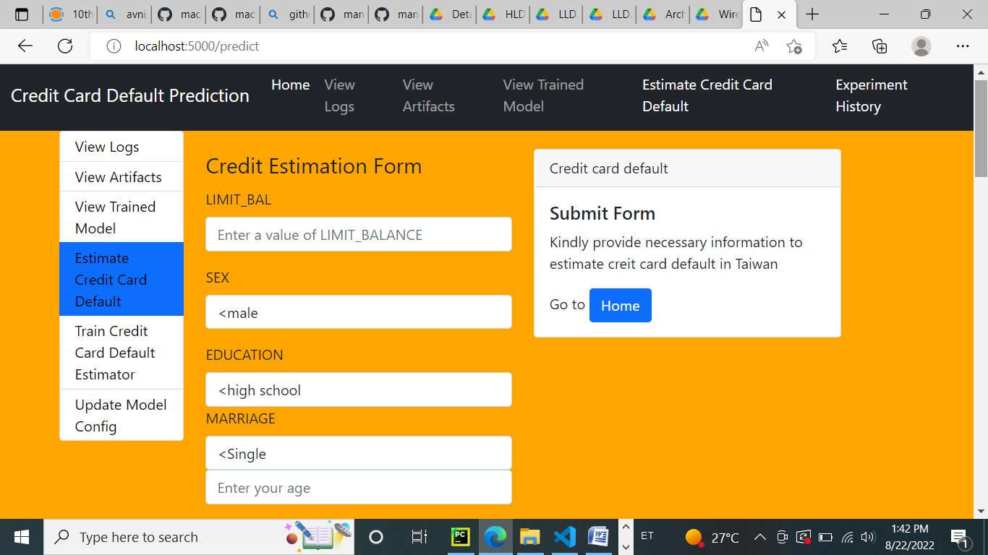

  7 Unit Test Cases

|  |  |  |
| --- | --- | --- |
| Test Case Description | Pre-Requisite | Expected-Result |
| Verify whether the  Application URL is  accessible to the user | 1. Application URL  should be defined | Application URL should be accessible to the user. |
| Verify whether the  Application loads completely  for the user when the URL is  accessed. | 1. Application URL is Accessible.  2. Application is  deployed. | The application should load completely for the user  when the URL is accessed. |
| Verify whether user can edit all the input fields | 1. Application URL is Accessible.  2. Application loads completely for the  user.  3. All the input fields Loaded. | User should be able to edit  all the input fields |
| Verify whether user gets “Predict” button to make predictions on the given inputs | 1. Application URL is Accessible.  2. Application loads completely for the  user.  3. All the input fields Loaded. | User should get a “Predict” button to make predictions  on the given inputs. |
| Verify whether user is  Presented with  recommended results on  clicking the “Predict” button | 1. Application URL is Accessible.  2. Application loads completely for the  user.  3. All the input fields Loaded. | Users should be presented with recommended results  on clicking the “Predict”  button. |